|  |  |  |
| --- | --- | --- |
|  | |  |
|  | | Engineering Design Document |
|  | |  |
|  | Description of the subsystem Processor for SecurityFramework  **Version: 1.1**  **Last Revised:**  **Author: Viktor Grytsay** | |

Table of Contents

Оглавление

1 System Overview 4

2 Assumptions and Dependencies 4

3 Technical Design 4

3.1 Function of the processor 4

3.2 Classes and interfaces 5

4 Example configuring engine of processor. 9

5 Error list 10

6 Outstanding Issues 10

Document Version History

|  |  |  |  |
| --- | --- | --- | --- |
| **Author** | **Revision No.** | **Date** | **Description of Change** |
| **Viktor Grytsay** | 1.0 | 10/07/2010 | First revision |
|  |  |  |  |
|  |  |  |  |
|  |  |  |  |

Functional Design Review

| **Name** | **Title** | **Date Reviewed** | **Date Approved** |
| --- | --- | --- | --- |
| **Kyle Quest** | Architect |  |  |
| **Anatoliy Lokshin** | Development lead |  |  |
| **Yulia Kuchmai** | QA Representative |  |  |
|  |  |  |  |

Technical Design Review

| **Name** | **Title** | **Date Reviewed** | **Date Approved** |
| --- | --- | --- | --- |
| **Kyle Quest** | Architect |  |  |
|  |  |  |  |
|  |  |  |  |

Engineering Task Worklist Review

| **Name** | **Title** | **Date Reviewed** | **Date Approved** |
| --- | --- | --- | --- |
| **Anatoliy Lokshin** | Development lead |  |  |
|  |  |  |  |
|  |  |  |  |

References

|  |  |  |
| --- | --- | --- |
| **Document Name** | **Author** | **Location** |
| Processor subsystem requirements.docx | Anatoliy Lokshin | http://seceng.metratech.com/gf/download/docmanfileversion/37/104/Processorsubsystemrequirements.docx |
|  |  |  |

Version Configuration

|  |  |  |
| --- | --- | --- |
| **Name** | **Version** | **Additional Comments** |
| MetraNet | 6.05 |  |
|  |  |  |

# System Overview

This document describes the processor subsystem, which allows to create simple and still powerful mechanisms for the client application protection, based on the individual parts of the functionality of various subsystems.

# Assumptions and Dependencies

Processor depends on the configuration loader subsystem.

# Technical Design

## Function of the processor

Processor consists of a set of Engines. These engines form a chain of handlers for input data.

They are united into one engine – **ProcessorEngine.** Rules for this engines are stored in configuration file for processor subsystem.

The transition from one rule to another is accompanied by testing for the presence of malicious code. Job processor-pipeline always completes stop-rule. Reasons shutdown of the processor:

1. When there is no malicious code is discovered. Processing completes normally.
2. When it detects malicious code at the time of handling.
3. On detecting cyclic data processing chain.

## Classes and interfaces

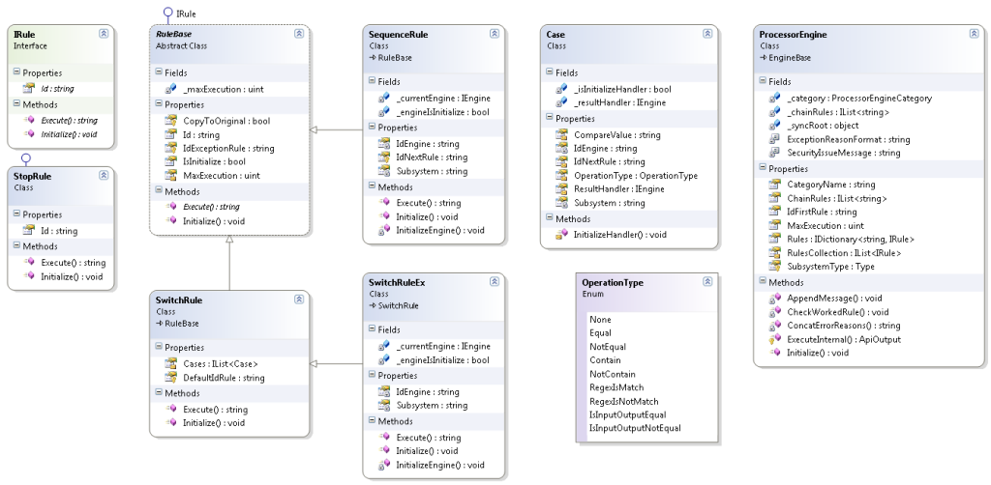

Pict.1 The basic classes of the processor subsystem

#### Class ProcessEngine.

It contains a chain of rules to process the input data.

Base properties:

| Property | Description |
| --- | --- |
| IdFirstRule | Required attribute.  Rule Id. This rule starts processing. |
| RulesCollection  (Mapped name is Rules) | Required attribute.  Rules collection. These rules process the input data. Default type for elements is **«MetraTech.SecurityFramework.SequenceRule».** If it's necessary to determine other rule type indicate it in **RealType** attribute. |
| MaxExecution | Required attribute.  Contains default value maximum executions count for rules in current engine. |
| CategoryName  (Mapped name is Category) | Required attribute.  Contains catgory name for current engine. |

#### Interface IRule

This interface contains declaration common properties and methods for all rule type.

| Property | Description |
| --- | --- |
| Id | Required attribute.  Contains id for current rule. |

Base methods.

| Method | Description |
| --- | --- |
| Execute | Handling the data in the current rule and return id next rule in chain of processor. |
| Initialize | Initializing members in current rule. |

#### Class StopRule.

Implementing interface **IRule**. Uses for declaring end processor chain.

#### Class RuleBase.

Abstract class. Contains base properties and function for all rule types.

Base properties:

| Property | Description |
| --- | --- |
| MaxExecution | Optional attribute.  Contains maximum executions count for current rule. |
| IdNextRule | Required attribute.  Contains id next rule in chain of processor. |
| IdExceptionRule | Required attribute.  Contains id next rule if data handling throw exception. |

#### Class SequenceRule.

This rule contains engine for handling input data. Engine id is in configuration file. Processing result is transferred to the following rule in chain of processor.

Base properties:

| Property | Description |
| --- | --- |
| IdEngine | Required attribute.  Contains current id engine. This engine is handler for input data. |
| Subsystem | Required attribute.  Contains subsystem name for current engine. |

#### Class SwitchRule.

This rule used for determination next element handling input data in chain of processor. Next rule determined by comparing input data with template. Property **Cases** contains templates collection.

Base properties:

| Property | Description |
| --- | --- |
| Cases | Required attribute.  Templates and conditions collection. They define the following rule for processing the request. |

#### Class SwitchRuleEx.

This rule combines functional of SwitchRule and SequenceRule.

Base properties:

| Property | Description |
| --- | --- |
| IdEngine | Required attribute.  Contains current id engine. This engine is handler for input data. |
| Subsystem | Required attribute.  Contains subsystem name for current engine. |

#### Class Case.

Contains the properties to determine the next rule.

Base properties:

| Property | Description |
| --- | --- |
| CompareValue | Required attribute.  Template for comparison with the result of data processing. |
| IdNextRule | Required attribute.  Rule id. Works if the malicious code is detected. |
| OperationType | Required attribute.  Contains comparison type. |
| Subsystem | Optional attribute.  Contains id subsystem for result handlers engine. |
| IdEngine | Optional attribute.  Contains engine id for result handler. |

#### Class Operation.

Compares the results of processing the input data with a template.

Base methods:

| Method | Description |
| --- | --- |
| Operate | Compares the results of processing the input data with a template. |

# Example configuring engine of processor.

Processor configuration:

<Engines>

<Engine Id="Unique_Id_engine" MaxExecution="UInt_value" Category="Category_name" IsDefault="True|False" IdFirstRule="Unique_rule_Id_1" RealType="MetraTech.SecurityFramework.ProcessorEngine">

<Rules>

Configuring sequence rules:

<Rule Id="Unique_rule_Id_1" MaxExecution="UInt_value" Subsystem="Subsystem_name"

IdEngine="Engine_Id" IdNextRule="Unique_rule_Id_2" IdExceptionRule="Unique_rule_Id_4"/>

<Rule Id="Unique_rule_Id_2" MaxExecution="UInt_value" Subsystem="Subsystem_name"

IdEngine="Engine_Id" IdNextRule="Unique_rule_Id_3" IdExceptionRule="Unique_rule_Id_4"/>

…

Configuring swich rules:

<Rule Id="Unique_rule_Id_3" MaxExecution="UInt_value"

RealType="MetraTech.SecurityFramework.SwitchRule"

IdNextRule="Unique_rule_Id_4" IdExceptionRule="Unique_rule_Id_4">

<Cases>

<Case CompareValue="String_or_Regex"

OperationType="None|Equal|NoTEqual|Contain|NonContain|RegexIsMatch|

RegexIsNotMatch|IsInputOutputEqual|IsInputOutputNotEqual"

IdNextRule="Unique_rule_Id_1"

IdEngine="Engine_Id"

Subsystem="Subsystem_name"/>

…

</Cases>

</Rule>

…

Configuring stop rules:

<item Id="Unique_rule_Id_4" RealType="MetraTech.SecurityFramework.StopRule" />

…

</Rules>

</Engine>

…

<Engines>

# Error list

The following table shows a listing of errors that can occur.

|  |  |  |  |
| --- | --- | --- | --- |
| **Error Code** | **Error Message** | **Description** | **Area** |
|  |  |  |  |
|  |  |  |  |

# Outstanding Issues

List all open issues regarding this document.

|  |  |  |  |  |  |  |
| --- | --- | --- | --- | --- | --- | --- |
| **ID** | **Date raised** | **Description and Resolution** | **Page/ Section** | **Raised by** | **Allocated to** | **Status** |
|  |  |  |  |  |  |  |
|  |  |  |  |  |  |  |